Project Documentation
On
“Online Hospital Management System”

Project Design and Build
By
SCHNEIDER MICHAEL

DEDICATION
This project is firstly to God almighty, who gave me the grace and strength to walk this path, though not easy but give me hope and knowledge to complete this project.
Secondly to my family and friends, they always advice and give me ideas on this project and am really lucky to have them.
And thirdly, I will give a big thanks to my tutor my director my Seniors Engineers MD and Pastor Rashid.

CONTENTS
- Introduction
              - Purpose
              - Scope
              - Technologies used
              - Overview
- Overall Description
- Goals of proposed system
- Background
- Project Requirements
- User Characteristics
- Constraints
- Definition of Problems
- Alternative Solutions
- Database Tables
- Software Snapshots
- Conclusion

- Introduction
- Purpose
- The Software is for the automation of Hospital Management.
- It maintains nine area type of users:-
- Administrator
- Doctor
- Nurse
- Patient
- Pharmacist
- Laboratory
- Accountant
- Security Guard
- Caretaker (Cleaner)
- The Software includes:-
- Maintaining Patient details.
- Providing Appointment and Prescription.
- Providing and maintaining all kinds of tests for a patient.
- Payment, Billing, Report generation and etc.
- Scope
It can used in any Hospital, Clinic, Dispensary or Pathology labs for maintaining patient details and their test result.
- Technologies used
This project is online software and it should be hosted online.

- Database Design (MYSQL)
- Front end:-
- JavaScript, CSS, Ajax, Html.
- Back end:-
- PHP.
- Framework:-
- Bootstrap.
- Overview
- Main facilities available in this project are:-
- Maintaining records of indoor/outdoor patients.
- Maintaining patients diagnosis details, advised tests to be done.
- Providing different test facilities to a doctor for diagnosis of patients.
- X-Ray
- Blood Test, etc.
- Maintaining Patient’s prescription and medicine.
- Providing billing details for indoor/outdoor patients.
- Maintaining backup of data as per user requirements.
- System name and data can be update, etc.
- Related of tests, prescription, appointment will be automatically updated in the database.
- Related of test report, patient details report, prescription and payment can be generated as per user requirements.
- Administrator or Doctor can search a patient’s record by his/her name or their ID or by gender.
- All Users can also edit their profile and also upload image for profile picture and password changed.

- Overall Description
- Goals of proposed system
- Planned approach towards working:- The working in the organization will be well planned and organized. The data will be stored properly in data stores. Which help in retrieval of information as well as its storage.
- Reliability:- The reliability of the proposed system will be high due to the above stated reasons. The reason for the increased reliability of the system is that now there would be proper storage of information.
- Accuracy:- The level of accuracy in the propose system will be higher. All operation would be done correctly and it ensures that whatever information is coming from the center is accurate.
- No Redundancy:- In the proposed system utmost care would be that no information is repeated anywhere, in storage or otherwise. This would assure economic use of storage space and consistency in the data stored.
- Immediate storage of information:- In manual system there are many problems to store the largest amount of information.
- Immediate retrieval of information:- The main objective of proposed system is to provide for a quick and efficient retrieval of information. Any type of information would be available whenever the user requires.
- Easy to Operate:- The system should be easy to operate and should be such that it can be developed within a short period of time and fit in the limited budget of the user.
- Background
A Hospital is a place where Patients come up for general diseases. Hospitals provide facilities like:-
- Consultation by Doctors on Diseases.
- Diagnosis for diseases.
- Facility for admitting Patients (providing beds, nursing, medicine etc.)
- Immunization for Patients/Children.
Various operational works that are done in a Hospital are:-
- Recording information about the Patients that come.
- Generating bills.
- Recording information related to diagnosis given to Patients.
- Keeping record of the Immunization provided to Children/patients.
- Keeping information about various diseases and medicine available to cure them.
These are the various jobs that need to be done in a Hospital by the operational staff and Doctors. All these works are done on papers.
The work is done as follows:-
- Information about Patients is done by just writing the Patients name, age and gender. Whenever the Patient comes up his information is stored freshly.
- Diagnosis information to patients is generally recorded on the document, which contains Patient information. It is destroyed after some time period to decrease the paper load in office.
- Immunization records of children are maintained in pre-formatted sheets, which are kept in a file.
- Information about various diseases is not kept as any document. Doctors themselves do this job by remembering various and medicines.
All this work is done manually by the receptionist and other operational staff and lot of papers are needed to be handled and taken care of. Doctors have to remember various medicines available for diagnosis and sometimes miss better alternatives as they can’t remember them at that time.
- Project Requirements
- Good storage (Database)
- User Characteristics
Every user should be:
- Comfortable and experienced of working with computer.
- He must have knowledge in medical field.
- He must also have basic knowledge of English too.
- Constraints
- Login and password is used for identification of user.

- Definition of problems
- Lack of immediate retrievals:- The information is very difficult to retrieve and to find particular information like- E.g. To find out about the patient’s history, the user has to go through various registers. The result in inconvenience and wastage of time.
- Lack of immediate information storage:- The information generated by various transaction takes time and efforts to be stored at right place.
- Lack of prompt updating:- Various changes to information like patient details or immunization details of child are difficult to make as paper to work is involved.
- Error prone manual calculation:- Manual calculations are error prone and take a lot of time this may result in incorrect information. For example calculation of patient’s bill based on various treatment.
- Preparation of accurate and prompt reports:- This becomes a difficult task as information is difficult to collect from various registers.

- Database Tables
- Login Table:-
Field Name | Data Type
Email/Phone | Text
Password | Text

- This table indicate login table with Email/Phone Number. The user can login with his/her email or phone number the one the user use during registration.

- Registration Table:-
Field Name | Data Type
Name | Text
Email Address | Text
Password | Text
Address | Text
Phone Number | Text
Register-Date Time | Date Time

- This table show the information for a user before user can added to the system and the user can be register only by the Administrator. User can also edit his/her data later once he/she is added.

- Software Snapshots
- Login Area for all Users (Administrator, Doctor, Patients, etc.)
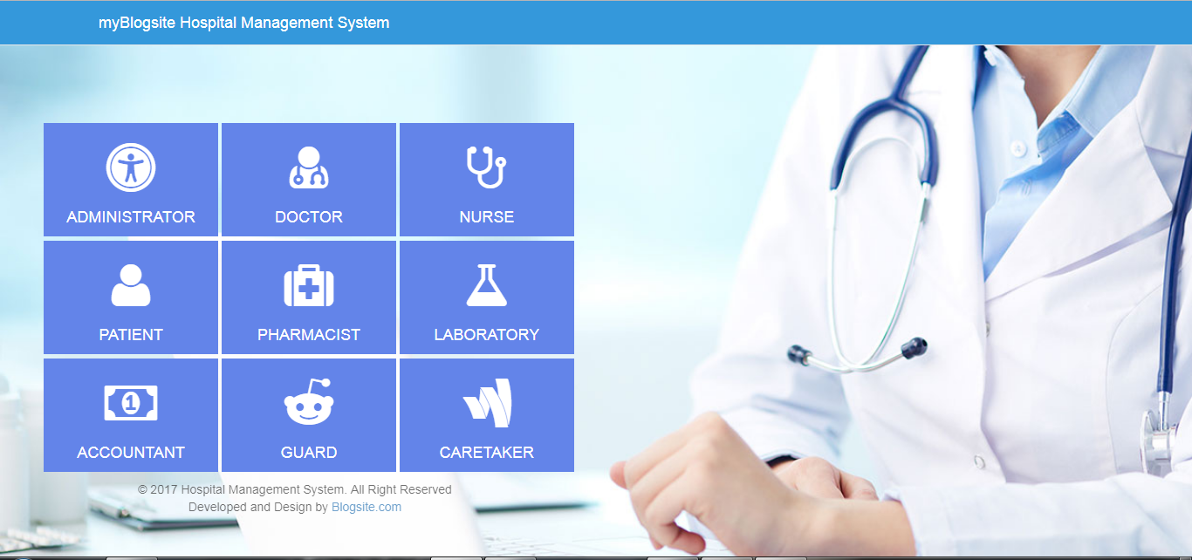

- Login Form (same as all Users.)
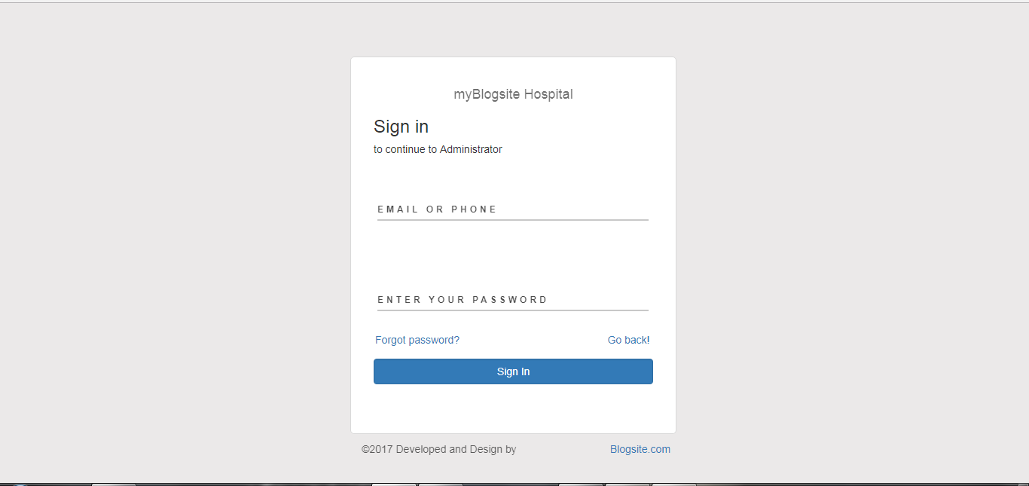

- Home Page (Administrator Home Page.)
Notice: Administrator homepage is far different from doctor homepage and same as doctor homepage too is different. They are not the same.
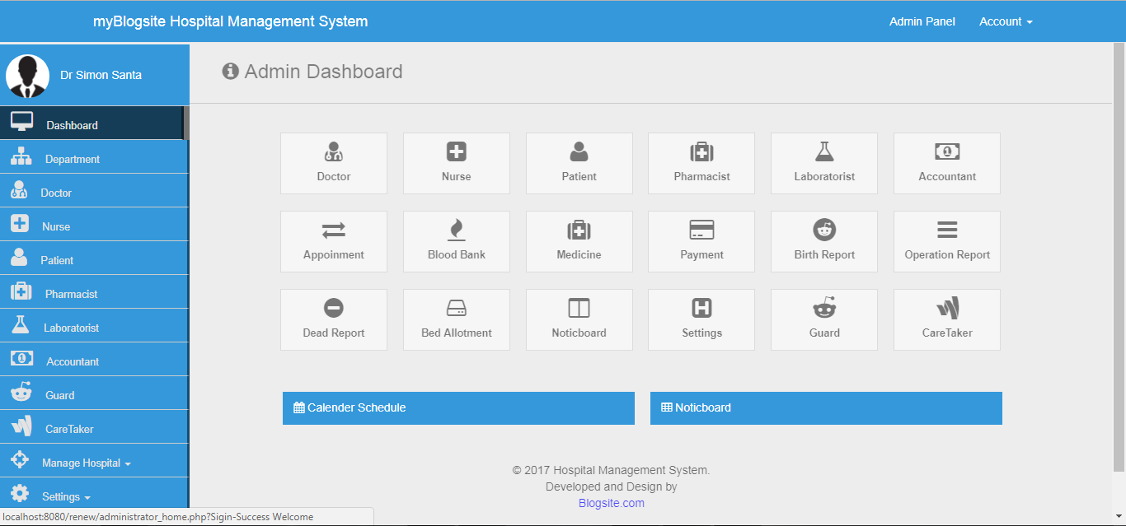

- Registration page for registering Caretaker
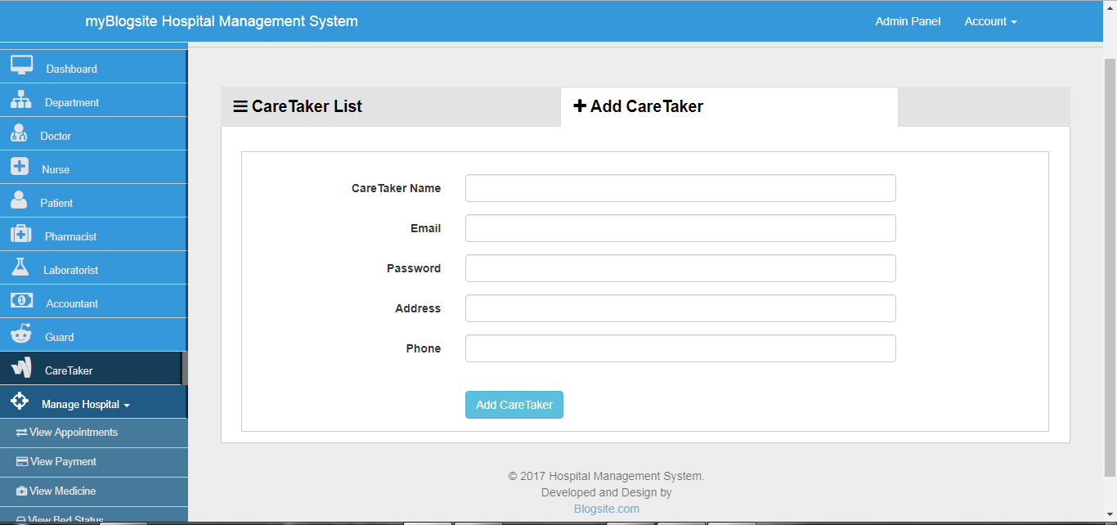

- Record of showing admins for Caretaker.
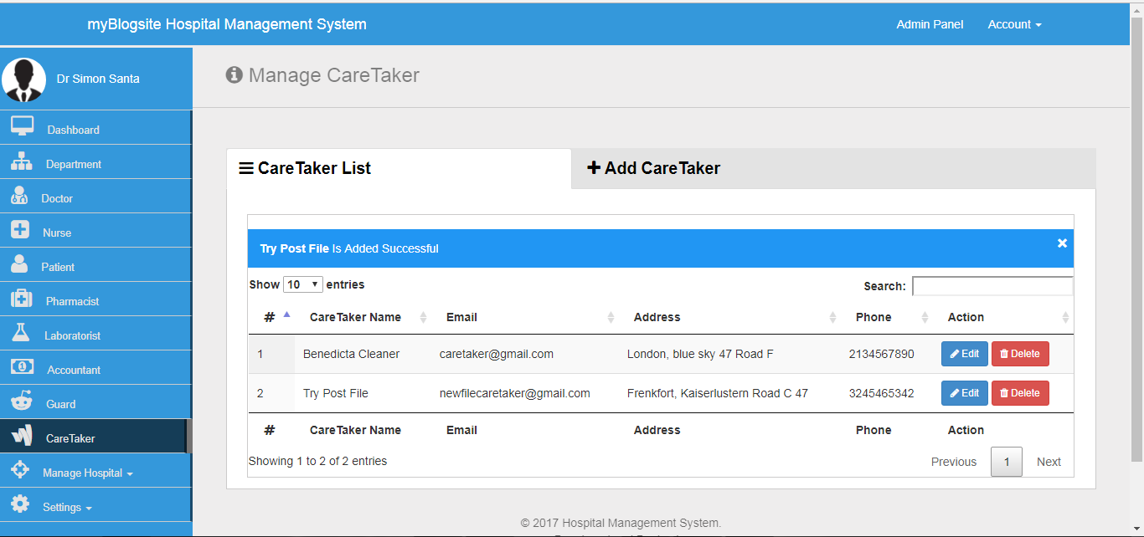
Notice: it also show success message when adding new caretaker. It will show successful message when caretaker is successful register. Remember if the administrator want to edit Caretaker data is allow and also to delete it also allow for administrator.

- Error message when registering fail
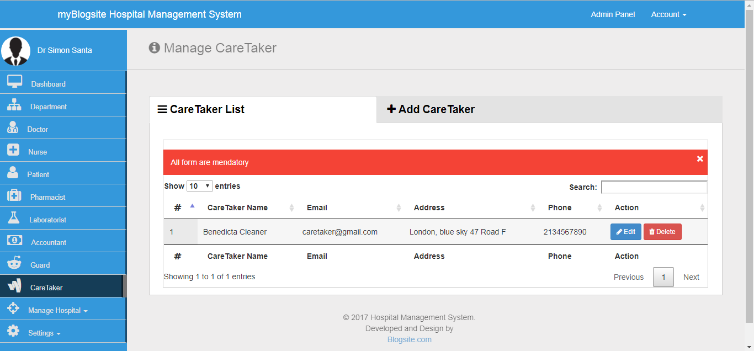
Notice: warning message let the administrator know that it fail to do what the admin want to do.

- Edit Profile (Administrator profile.)
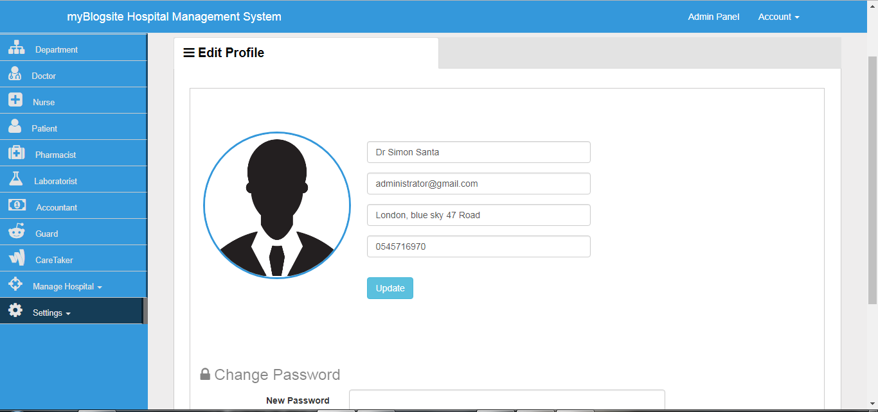
Notice: This page show where the administrator can edit his/her data like name and more and also administrator can change password too.
To see or view all demo click on the link below to watch full demo
Both part 1 and part 2.
- Part 1: https://www.youtube.com/watch?v=L36FTR3FH5I
- Past 2: https://www.youtube.com/watch?v=hrsmDynFXeY

- Conclusion
This project Online Hospital Management System (OHMS) is for computerizing the working in a hospital. The software take care of all the requirement of an average hospital and is capable to provide easy and effective storage of information related to patients that come up to the hospital.
This software can also be upgraded by adding more features to it. It also generates test reports; provide prescription details including various tests and more.
This system also provides the facility of backup as per the requirement.

